LAB MANUAL 6
TAHA MUZAMMIL
456279
TASK 1
#include <iostream>
using namespace std;
int main() {
int x;

// Get the number of terms in the Fibonacci sequence needed
cout<< "how many numbers of the Fibonacci sequence are needed: ";
cin>> x;
int a=0,b=1,c;
cout<< "Fibonacci Sequence: ";
for (int i = 0; i < x; ++i) {
cout<< a << " ";
c=a+b;
a=b;
b=c;
// calculate the first and second number and update them for next iteration
}
}
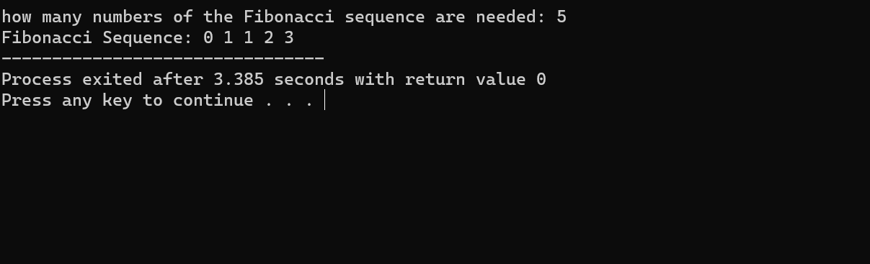

Task 2
#include <iostream>
using namespace std;
int main()
{
int x;
cout<< "Enter the number of rows for Floyd's Triangle: ";
cin>> x;
int num = 1;
for (int i = 1; i <= x; ++i) {
for (int j = 1; j <= i; ++j) {
cout<< num << " ";
++num;
}
cout<<endl;
}
}
